Department of Informaton and Communicaton Technology
Faculty of Technology
University of Ruhuna



Faculty of Technology
Academic Management System
Group No : 01
Software Requirements Specification (SRS)
Course: ICT2132 — Object Oriented Programming Practicum
Group Members :-
TG/2024/2061 – Amjad M.H.M.
TG/2024/2097 – Preamathunga I.D.N.S.
TG/2024/2139 – Kalhara W.K.C.
TG/2024/2140 – Wickramasooriya A.J.C.

1. Introduction

1.1 Purpose
This SRS defines the functional, data, interface, quality, and object-oriented design requirements for a Java and MySQL desktop application that manages academic information for the Faculty of Technology. It is the baseline for analysis, design, implementation, testing, and demonstration in ICT2132.

1.2 Scope
The system manages role-based profiles, courses, materials, attendance, medical records, configurable assessments and marks, eligibility, grades, SGPA, CGPA, notices, timetables, and reports. It supports Admin, Lecturer, Technical Officer, and Undergraduate users. It is not an online student portal or a learning-management system.

1.3 Product Perspective
The product is a standalone, single-institution desktop information system using a Java GUI and a central MySQL database. It replaces fragmented spreadsheets and manual calculations with controlled data entry, consistent calculations, and read-only views appropriate to each role.

1.4 Definitions and Acronyms
Term | Meaning
CA | Continuous Assessment mark for an enrolled course; it is used for eligibility.
SGPA / CGPA | Semester / cumulative Grade Point Average, calculated as credit-weighted grade points.
Batch-missed | A student who follows a course with a later or different batch because the original scheduled attempt was missed.
Repeat student | A student repeating a course attempt under the institution's approved academic process.
DAO | Data Access Object: Java class that isolates SQL/database operations.

1.5 References
[R1] University Grants Commission, Sri Lanka, Commission Circular No. 12/2024: Guidance of the Grading System of Degree Programmes offered under Technology Stream, 11 October 2024. The circular states that the amended guidance applies to Technology-degree students enrolled from the 2022/2023 batch onward. [R2] MySQL 8 Reference Manual. [R3] Java Platform, Standard Edition documentation.

2. Overall Description

2.1 Product Perspective
The system has one source of truth for academic records. The GUI sends validated requests to controllers/services; services apply academic rules; DAOs use transactions to read and update MySQL records.

2.2 Product Functions
- Authenticate users and show a dashboard based on their role.
- Maintain profiles, courses, components, assessments, notices, and timetables.
- Record theory/practical attendance and approved medical evidence.
- Capture configurable assessments, calculate CA, eligibility, final marks, grades, SGPA, and CGPA.
- Provide batch, course, and student reports without granting unapproved edit access.

2.3 User Classes
User class | Typical knowledge | Primary responsibility
Admin | Trained staff user | Master data, accounts, notices, timetables
Lecturer | Academic staff | Materials, assessment marks, academic views
Technical Officer | Laboratory/support staff | Attendance and medical records
Undergraduate | Student | Own permitted profile and academic information

2.4 Operating Environment
Java SE 17+ desktop client (Swing or JavaFX), JDBC driver, MySQL 8+, Windows/Linux laboratory or office PCs, and a local/institutional network connection to MySQL.

2.5 Constraints
The application must use Java, MySQL, a GUI, and demonstrable OOP concepts. Every mark is out of 100. It must operate offline from the public Internet, except where the institution later chooses hosted database infrastructure.

2.6 Assumptions
Assumption A-01. The faculty supplies authorised course offerings, enrolments, timetable data, and final local approval for academic policies. This mini project implements those approved records; it does not replace Senate or examination-board decisions.

2.7 Dependencies
MySQL availability, JDBC configuration, Java runtime, accurate timetable setup, and authorised staff data entry are required for correct operation.

3. System Overview

Inputs
Profiles, course and component data, assessment definitions, marks, session attendance, medical details, notices, timetable entries.

Outputs
Role dashboards, attendance percentages, medical status, eligibility, grade/result views, SGPA/CGPA, and printed/exportable reports.
Calculation scope: Grade and GPA calculations use the grading scheme stated in Section 7. If a Faculty regulation differs from the published guidance, the administrator must configure the approved scheme and retain the approval reference; the system must not silently change historical results.

4. Functional Requirements
- FR-001 The system shall authenticate an active user by username and password and load only the functions assigned to the user role.
- FR-002 Admin shall create, read, update, deactivate, and maintain Admin, Lecturer, Technical Officer, and Undergraduate profiles.
- FR-003 Admin shall create and maintain departments, batches, courses, course offerings, components, notices, and timetables.
- FR-004 Lecturer and Technical Officer shall update their own profile except username and password; undergraduates shall update only contact details and profile picture.
- FR-005 Lecturer shall add and modify course materials for assigned course offerings.
- FR-006 The system shall allow configured assessment types per course offering, rather than assuming one common evaluation pattern.
- FR-007 Lecturer shall enter and revise marks out of 100 for authorised assessments and view them by student, batch, subject, and CA.
- FR-008 Technical Officer shall create and maintain timetable-linked theory and practical attendance sessions and records for current-semester modules.
- FR-009 The system shall show theory-only, practical-only, and combined attendance where both components exist.
- FR-010 Technical Officer shall create and maintain medical records; authorised users shall view their permitted medical records.
- FR-011 The system shall calculate attendance, CA, attendance eligibility, CA eligibility, and final examination eligibility.
- FR-012 The system shall calculate final marks, grades, grade points, SGPA, and CGPA and show supporting courses, credits, marks, and grades.
- FR-013 Users shall view notices and authorised timetable views; Technical Officers view only their department timetable.
- FR-014 The system shall produce the reports listed in Section 22 and keep an audit record of sensitive changes.

5. User Roles and Permissions

5.1 Major-module permission matrix
Module / role | Admin |  |  |  | Lecturer |  |  |  | Technical Officer |  |  |  | Undergraduate
 | C | R | U | D | C | R | U | D | C | R | U | D | C | R | U | D
User & profiles | ✓ | ✓ | ✓ | ✓* | — | own/student | own | — | — | own | own | — | — | own | limited | —
Courses / offerings | ✓ | ✓ | ✓ | ✓* | — | assigned | — | — | — | department | — | — | — | enrolled | — | —
Materials | — | — | — | — | ✓ | ✓ | ✓ | ✓ | — | — | — | — | — | enrolled | — | —
Attendance / medical | — | ✓ | — | — | — | ✓ | — | — | ✓ | ✓ | ✓ | ✓ | — | own | — | —
Assessments / marks | — | ✓ | — | — | ✓ | ✓ | ✓ | authorised | — | — | — | — | — | own results | — | —
Notices / timetables | ✓ | ✓ | ✓ | ✓ | — | ✓ | — | — | — | department | — | — | — | ✓ | — | —
C=Create, R=Read, U=Update, D=Delete. *Delete means soft-delete/deactivate where dependent academic records exist; hard deletion is prohibited. “Authorised” means assigned course/department and permitted current semester scope.

5.2 Access-control requirements
FR-015 Each request shall be checked by the service layer, not only by hiding GUI buttons. FR-016 A user shall never read or change a record outside the role and data scope in this matrix.

6. Detailed Module Requirements

6.1 Authentication & Authorisation
Purpose/actors: secure role-based access for all users. Pre/post: active account exists → authenticated session and role dashboard. Inputs: username, password. Processing/output: validate, compare password hash, log event, return dashboard or error. Validation/errors: blank/invalid credentials, locked/inactive account, unauthorised action.

6.2 User, Student, Lecturer & Technical Officer Management
Purpose/actors: Admin maintains role profiles; each role maintains permitted own fields. Pre/post: authorised actor → valid linked user/role profile is saved or deactivated. Inputs: identity, contact, department/batch/status details. Processing/output: check unique username/student ID, validate role scope, save profile; updated profile/list. Errors: duplicate identity, invalid email/phone, missing role link.

6.3 Course Management
Purpose/actors: Admin defines courses, offerings, credits, theory/practical components and enrolments. Pre/post: department exists → current-semester offering is available to authorised data entry. Inputs: code, title, credits, components, semester, batch. Processing/output: validate code/credits, prevent duplicate offering, save; course catalogue and offering view. Errors: invalid credit/component, duplicate course code, enrolment conflict.

6.4 Course Material Management
Purpose/actors: Lecturer publishes resources for assigned offerings. Pre/post: assignment exists → material metadata/path is available to enrolled students. Inputs: title, description, controlled file path/link. Processing/output: verify course ownership and file metadata; material list. Errors: unsupported file reference, missing title, unassigned lecturer.

6.5 Attendance Management
Purpose/actors: Technical Officer records timetable-linked current-semester attendance; lecturer/student read authorised views. Pre/post: offering, component, and timetable slot exist → one attendance record per student/session. Inputs: session date, component, enrolled students, presence. Processing/output: prevent duplicates, calculate counts/percentages; batch/student/component reports. Errors: session outside semester, absent enrolment, duplicate record, invalid component.

6.6 Medical Management
Purpose/actors: Technical Officer maintains submitted medical evidence and approval. Pre/post: student/enrolment exists → medical status is retained and used by eligibility rule. Inputs: student, course/period, date, reason, evidence reference, status. Processing/output: validate date/range, store pending/approved/rejected; medical view and eligibility input. Errors: future date, missing reason, overlapping duplicate record.

6.7 Assessment & Marks Management
Purpose/actors: Lecturer configures assessment components and records marks. Pre/post: lecturer assignment and offering exist → marks are saved against an assessment/enrolment. Inputs: assessment type/name, weight, CA flag, mark 0–100. Processing/output: validate total configured weights and mark range; mark, student, batch, subject, and CA views. Errors: duplicate assessment/mark, weight total invalid, unauthorised course, mark outside range.

6.8 Eligibility, Grade & SGPA/CGPA Management
Purpose/actors: system calculates academic outcomes; lecturer/student read authorised views. Pre/post: required attendance and marks exist → derived eligibility/result snapshot is displayed. Inputs: attendance records, medical approval, assessment marks, credits. Processing/output: apply Sections 7 and 16 rules; eligibility, grades, SGPA/CGPA with supporting courses. Errors: incomplete configured assessment, unavailable grade scheme, inconsistent credits.

6.9 Notice, Timetable, Reports, Profile & Dashboard
Purpose/actors: Admin publishes notices/timetables; all roles see scoped dashboards and reports. Pre/post: authorised record exists → targeted users receive readable current information. Inputs: title/body/audience/date or timetable slot/location. Processing/output: validate time collisions and audience; filtered views/reports. Errors: expired/blank notice, timetable overlap, invalid target audience.

7. Business Rules
ID | Rule
BR-001 | Only an active user with a verified password hash may create an authenticated session.
BR-002 | Role permission and data scope must be enforced for every create, read, update, delete, and report operation.
BR-003 | Each student may have one active enrolment per course offering; repeat/batch-missed attempts are separate enrolment records with an attempt number and status.
BR-004 | Every assessment belongs to one course offering, has a configurable type, and records marks from 0 to 100.
BR-005 | CA eligibility is true only when the calculated CA mark is at least 40.00%.
BR-006 | Attendance percentage for a component = (eligible attended sessions ÷ scheduled sessions) × 100. A theory/practical view uses only the matching component. Combined percentage = (eligible attended theory + practical sessions) ÷ (scheduled theory + practical sessions) × 100.
BR-007 | The standard scheduled count is 15 theory sessions and 15 practical sessions for a component offered in the current semester. A one-credit theory/practical component represents two contact hours per session; credits define course load, not a multiplier for the session percentage.
BR-008 | Assumption: attendance eligibility requires at least 80.00% in every required component. For a course with both components, the combined value is displayed, but eligibility requires each required component to meet 80% unless the Faculty formally approves a different policy.
BR-009 | Assumption: an approved medical record may convert eligible absence sessions within its approved date range into medical-excused sessions for the attendance calculation; those sessions are removed from the denominator, not counted as present. Rejected/pending medical records do not change attendance.
BR-010 | Final examination eligibility is true only if CA eligibility and attendance eligibility are both true. The system shall display the failed condition(s).
BR-011 | Final mark is the sum of each configured assessment mark × its configured weight / 100. Weights for a published assessment plan must total 100%.
BR-012 | The grade scheme and grade points follow the Technology-stream guidance of UGC Circular 12/2024 for applicable cohorts. The approved scheme is versioned so historic results remain reproducible.
BR-013 | SGPA = Σ(course credit × grade point) ÷ Σ(course credits counted in that semester). CGPA = Σ(course credit × grade point across counted completed attempts) ÷ Σ(counted course credits). Values display to two decimals.
BR-014 | Assumption: for a repeated course, the approved result-selection rule must be set by the Faculty; the mini-project default is to include the latest completed attempt in CGPA and retain all attempts for audit.
BR-015 | Passwords are never stored in plaintext. Profile image storage uses a controlled file path/UUID in the database; the GUI validates type and access location.

7.1 Verified grading reference
The official circular is cited in [R1]. The table below represents the published Technology-stream scale used by this proposed system. Assumption: a programme-specific approved exception, if any, must be supplied by the Faculty before deployment and configured as a new scheme version.
Mark range | Grade | Grade point
85–100 | A+ | 4.00
80–84 | A | 4.00
75–79 | A− | 3.70
70–74 | B+ | 3.30
65–69 | B | 3.00
60–64 | B− | 2.70
55–59 | C+ | 2.30
50–54 | C | 2.00
45–49 | C− | 1.70
40–44 | D+ | 1.30
35–39 | D | 1.00
0–34 | E | 0.00

8. Non-Functional Requirements
ID | Requirement
NFR-001 | Normal list, login, and single-result operations shall respond within 3 seconds on the specified local network under expected class-size data.
NFR-002 | Passwords shall be salted and hashed using a modern Java-supported password-hashing algorithm; database credentials shall not be hard-coded in source control.
NFR-003 | GUI labels, validation messages, and workflow order shall be understandable to second-year users; critical actions require confirmation.
NFR-004 | All multi-table changes shall use database transactions; failed writes shall roll back and display a meaningful message.
NFR-005 | Layered Java classes, meaningful names, unit-testable services, and DAO interfaces shall support maintenance.
NFR-006 | The schema shall support additional courses, offerings, batches, assessments, and users without redesign.
NFR-007 | Foreign keys, unique constraints, checks, and application validation shall protect data integrity.
NFR-008 | Availability depends on the local Java client and MySQL service; the system shall recover gracefully from a temporary connection loss.
NFR-009 | Errors shall not expose SQL, password, or stack-trace details to ordinary users; technical detail is logged securely.
NFR-010 | Authentication and authorisation shall be checked at login and before protected service operations.
NFR-011 | Daily logical backup and periodic restore testing are required operational procedures; database backup files must be access-controlled.
NFR-012 | Log login attempts and create/update/delete events for marks, attendance, medical approvals, profiles, and master data with actor and timestamp.
NFR-013 | The application shall run on supported Windows/Linux Java environments and MySQL 8+ through JDBC.
NFR-014 | Keyboard navigation, readable labels, sufficient contrast, visible focus, and non-colour-only status indicators shall be used where practical in the desktop GUI.

9. Object-Oriented Design Requirements
Concept | Required use in this system
Classes & objects | Domain objects such as Course, Enrollment, Assessment, AttendanceSession, MedicalRecord, Notice, and Grade represent real academic concepts.
Encapsulation | Private fields with validated getters/setters; for example, Marks.setScore() rejects values outside 0–100 and Assessment.setWeight() rejects invalid percentages.
Inheritance & abstraction | Abstract User holds shared identity/authentication properties. Admin, Lecturer, TechnicalOfficer, and Undergraduate extend it and implement role-specific behaviour.
Interfaces | Repository<T>, Authenticatable, and EligibilityPolicy reduce coupling and permit substitution in tests.
Polymorphism / overriding | User.getDashboardPermissions() and EligibilityPolicy.evaluate() are invoked through common types but execute role/policy-specific implementations.
Access modifiers | Private data fields; protected shared user behaviour; public validated service APIs. DAO SQL helpers remain package-private/private where possible.
Exception handling | Custom ValidationException, AuthorizationException, NotFoundException, and DataAccessException are caught at controller boundaries and translated to safe GUI messages.
Database handling | DAO classes use JDBC prepared statements, result mapping, transactions, and try-with-resources; services must not build SQL in the GUI.
GUI | Views collect input and render models only; controllers coordinate views and services so business rules remain reusable/testable.

10. System Architecture
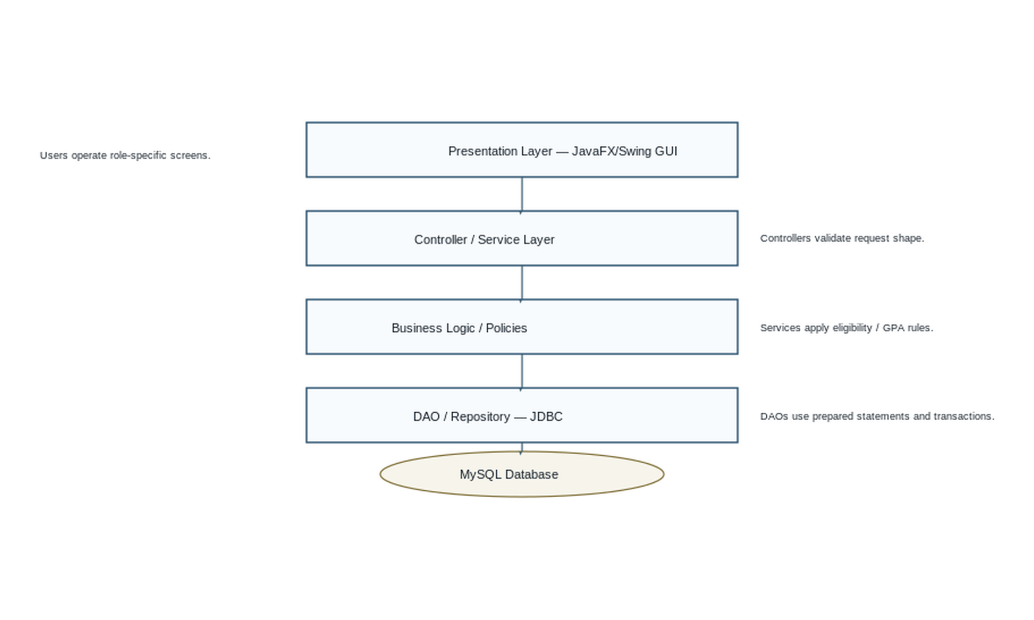
Figure 1. Layered architecture. Dependencies flow down; results/errors return to the GUI.

10.1 Authentication, connection and transaction flow
- GUI submits credentials to AuthController; AuthService obtains the active user through UserDAO and compares a password hash.
- Service creates a role-aware session object and writes an audit event; no plaintext password is retained.
- DAO obtains a JDBC connection from a configured connection provider. Prepared statements prevent SQL injection.
- For an atomic operation (for example, publish assessment and marks), the service starts a transaction, calls DAOs, commits only after all steps succeed, otherwise rolls back.
- Input validation occurs in GUI for immediate feedback and again in service/domain objects for protection. Exceptions are logged and converted to user-safe messages.

11. UML Diagrams

11.1 Use Case Diagram
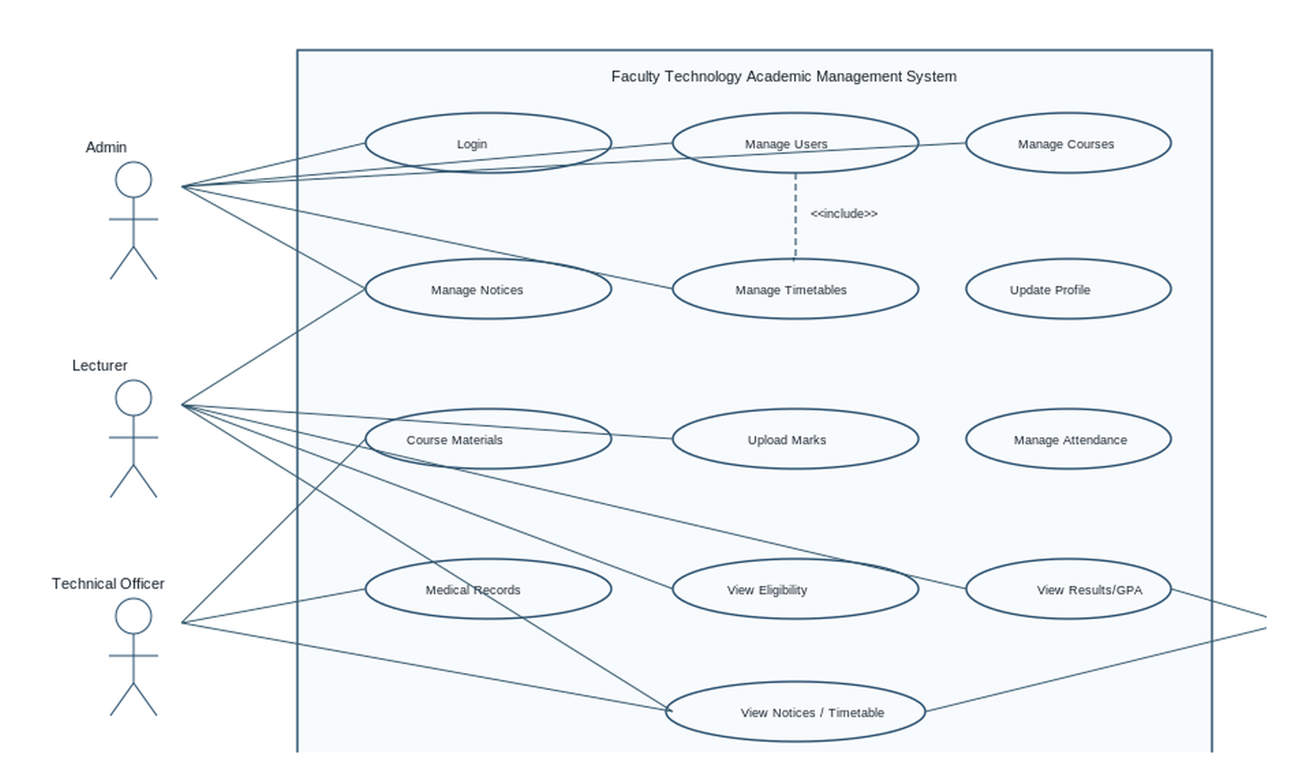
Figure 2. Major use cases. Dashed inclusion indicates that user management requires an authenticated session; other associations show permitted role use.

11.2 Detailed Class Diagram
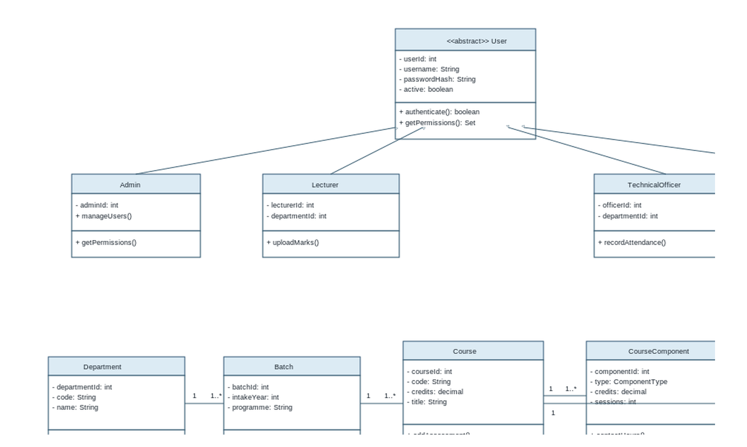
Figure 3. Domain class diagram. Course components and assessments are composed by a course offering; enrolment resolves student-to-course many-to-many associations.

12. DFD Diagrams

12.1 Level 0 Context Diagram
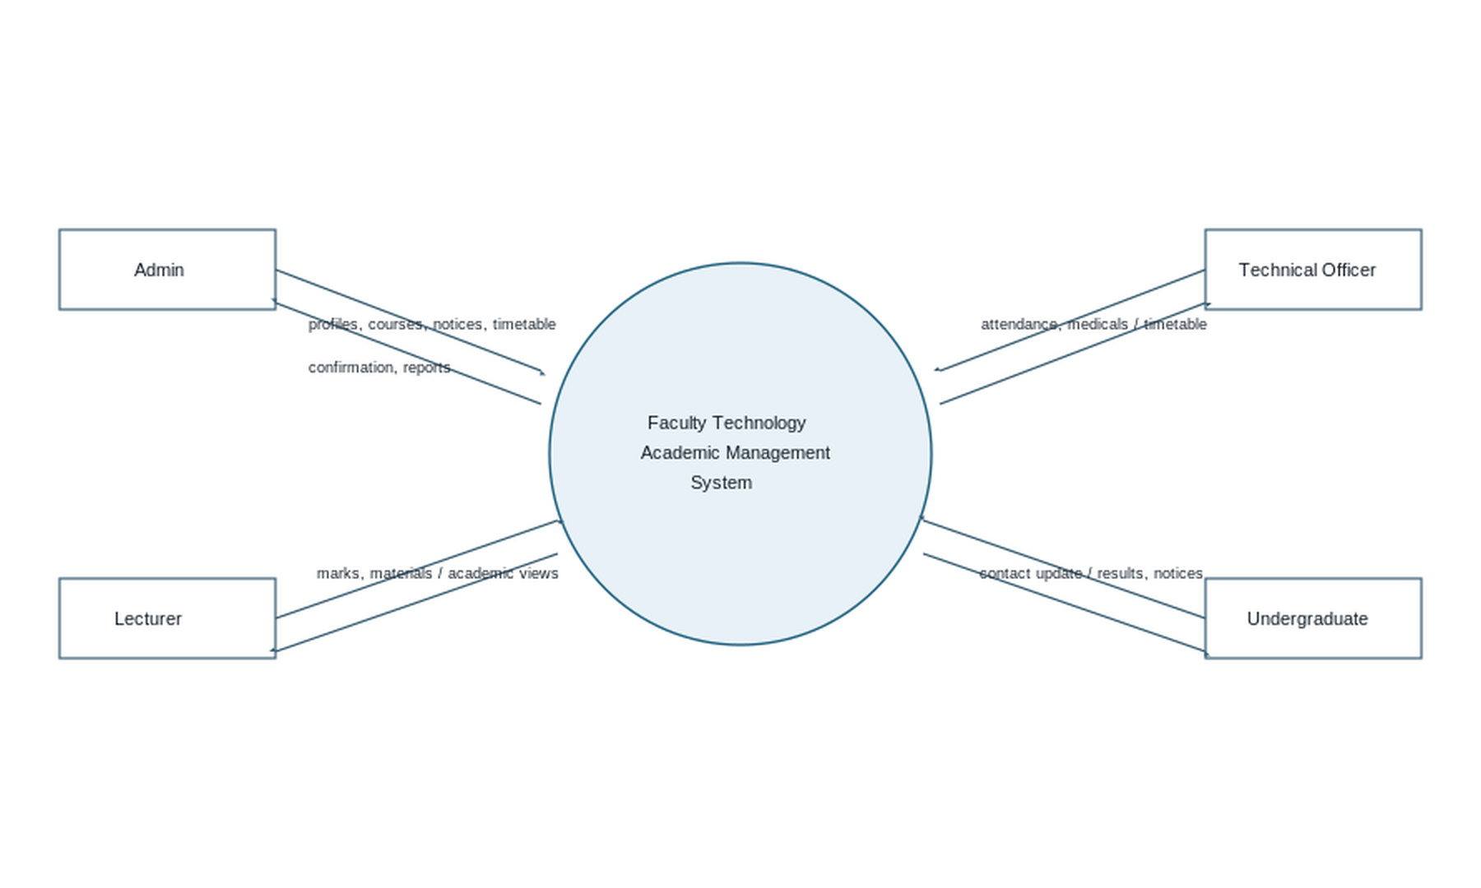
Figure 4. Context DFD: principal external entities and major information flows.

12.2 Level 1 DFD
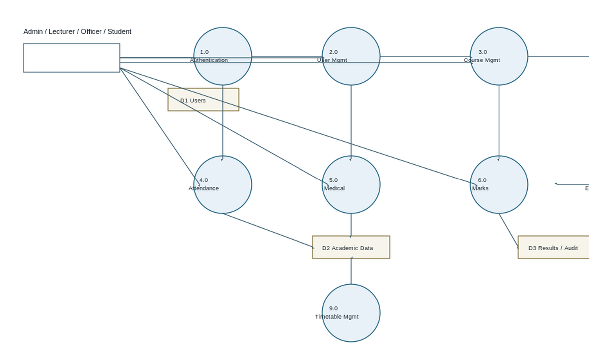
Figure 5. Level 1 DFD. D1 contains accounts; D2 course, attendance and medical information; D3 derived results and audit events.

13. Activity Diagrams
Each workflow begins at the filled circle, performs user/system actions, evaluates a decision, follows an alternate path where needed, and ends at the double circle.
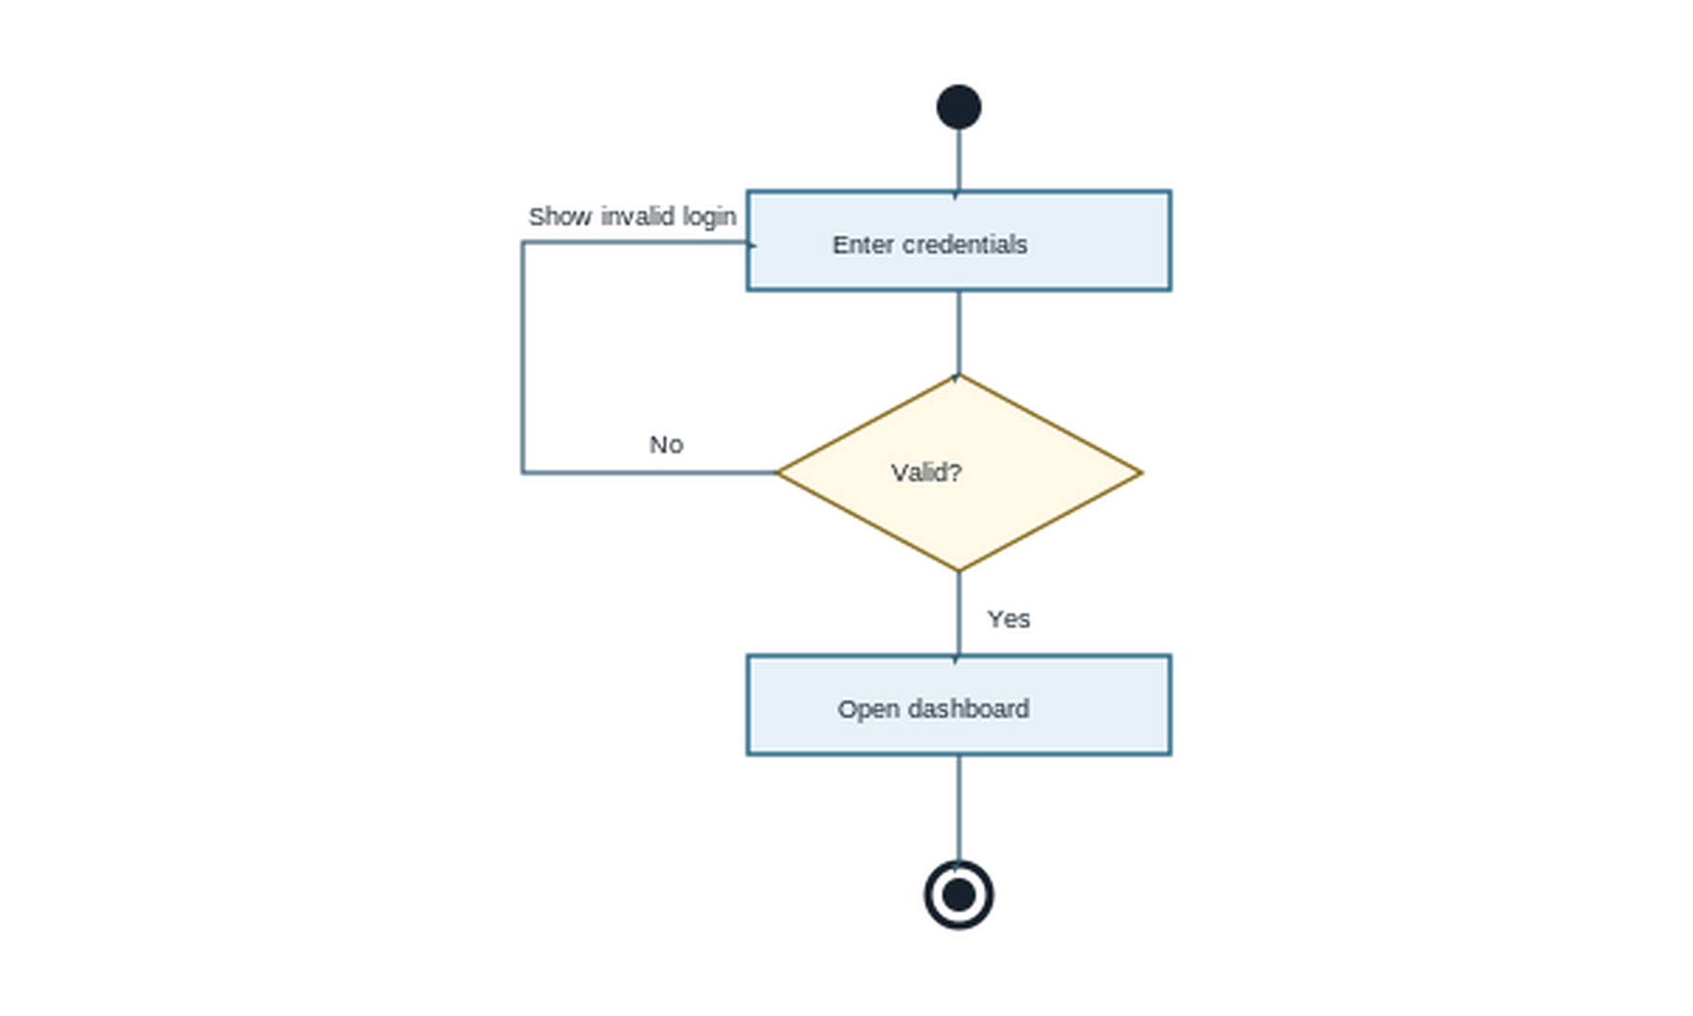
Figure 6. Login activity — alternative invalid-login path returns to credential entry.
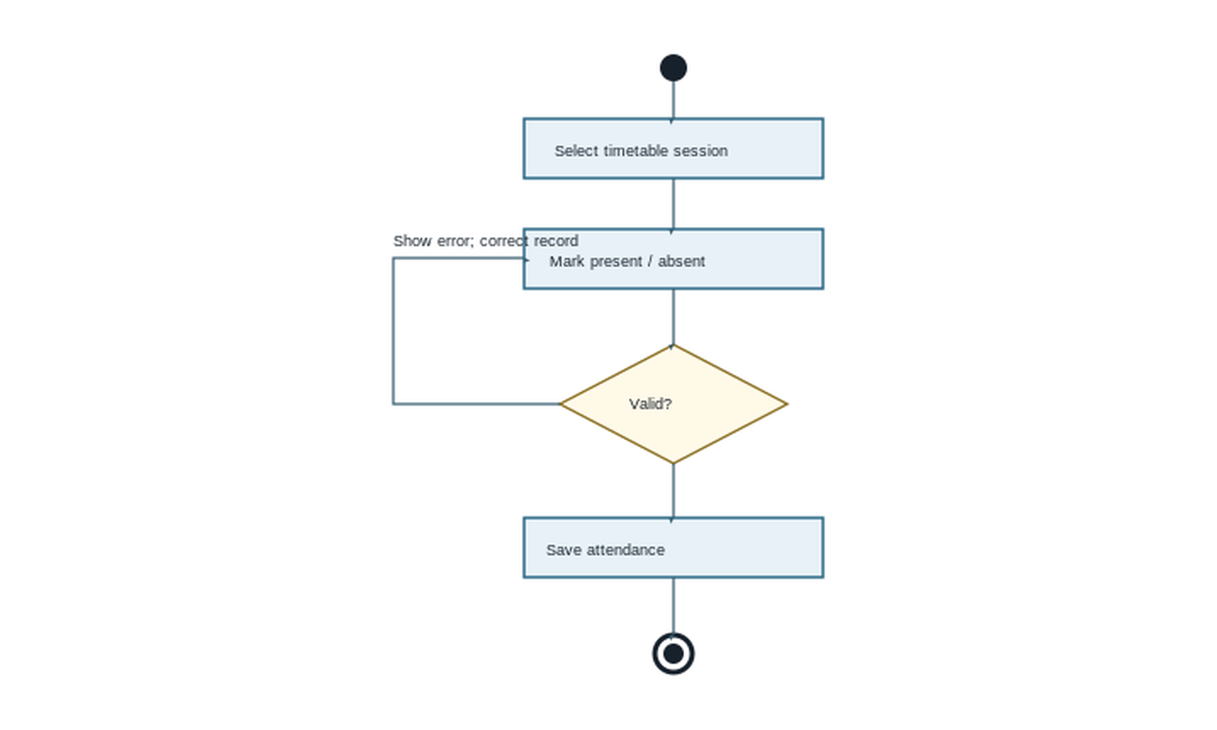
Figure 7. Attendance activity — verifies timetable, component and enrolment.
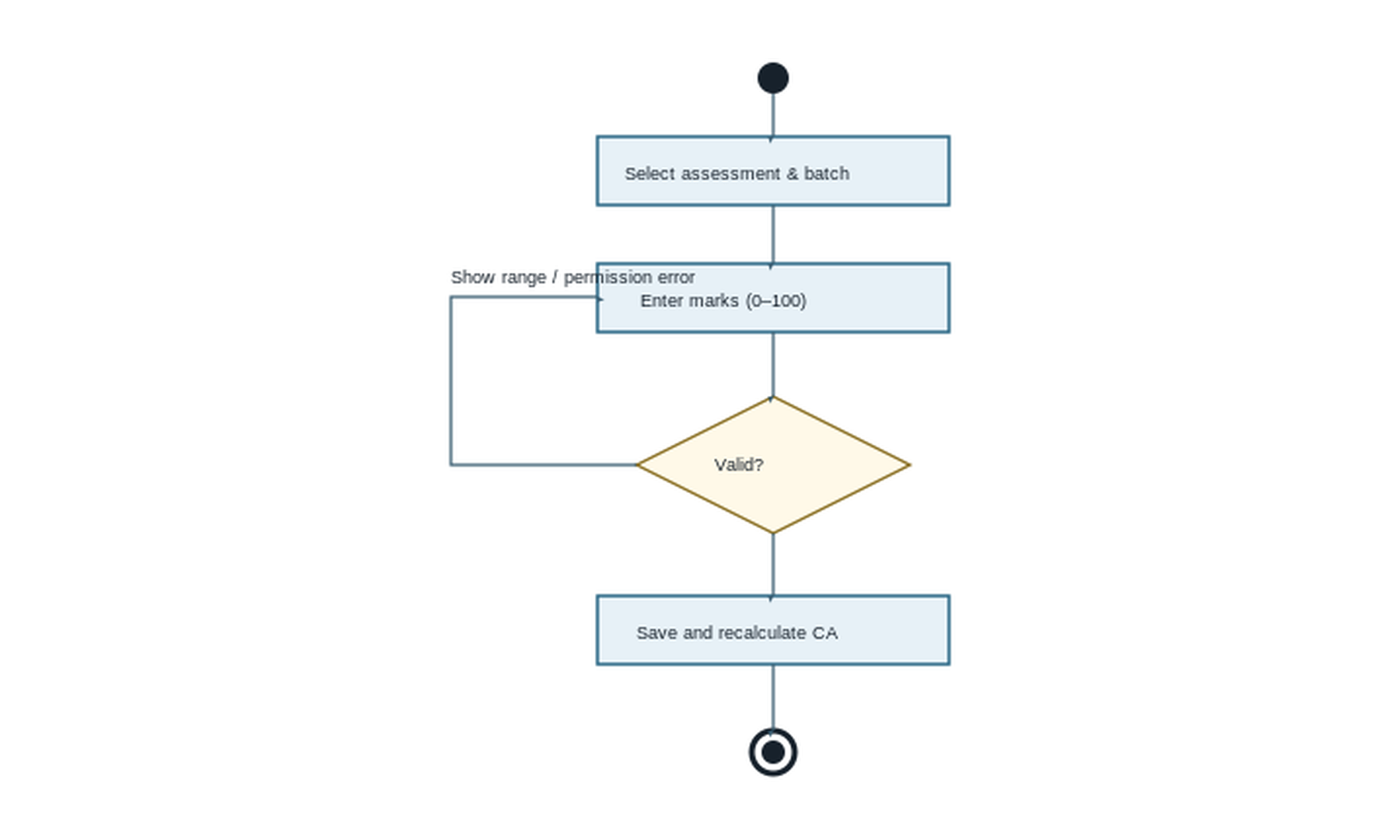
Figure 8. Upload marks activity — validation precedes persistence and CA update.
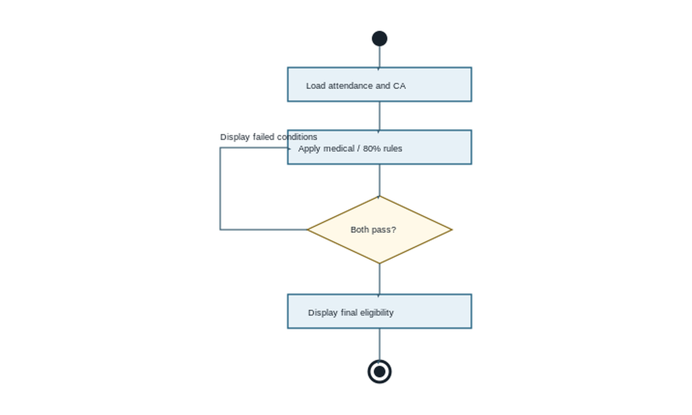
Figure 9. Eligibility activity — shows a reason when attendance or CA fails.
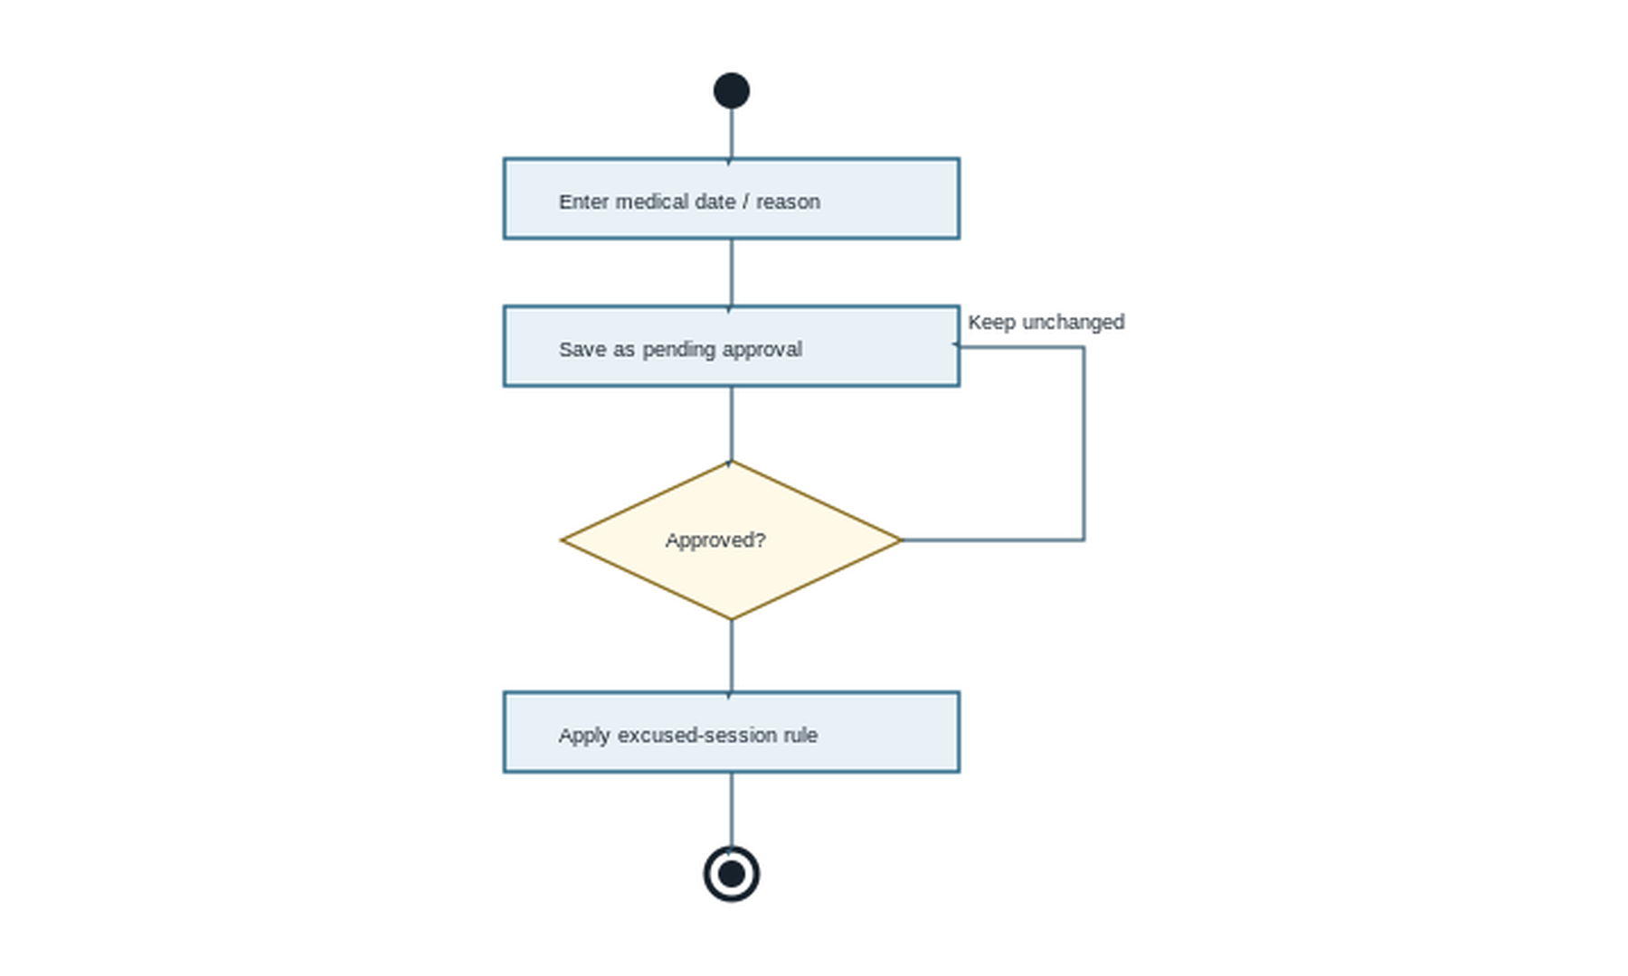
Figure 10. Medical activity — pending/rejected evidence does not change attendance.

13.1 Additional activity specifications
Workflow | Start → actions → decision/alternative → end
Calculate GPA | Start → select student/semester → load completed counted enrolments → verify credits/grades available → calculate weighted GPA or display incomplete-result reason → show SGPA/CGPA → end.
Manage Course | Start → Admin enters course/offering/components → validate unique code, credits and components → save or show validation error → show catalogue → end.
Publish Notice | Start → Admin enters title/body/audience/date → validate required fields and dates → publish or correct error → show filtered notice → end.

14. Sequence Diagrams
All sequences preserve the required path: GUI → Controller/Service → Business Logic → DAO → Database, with return values propagated back to the GUI.
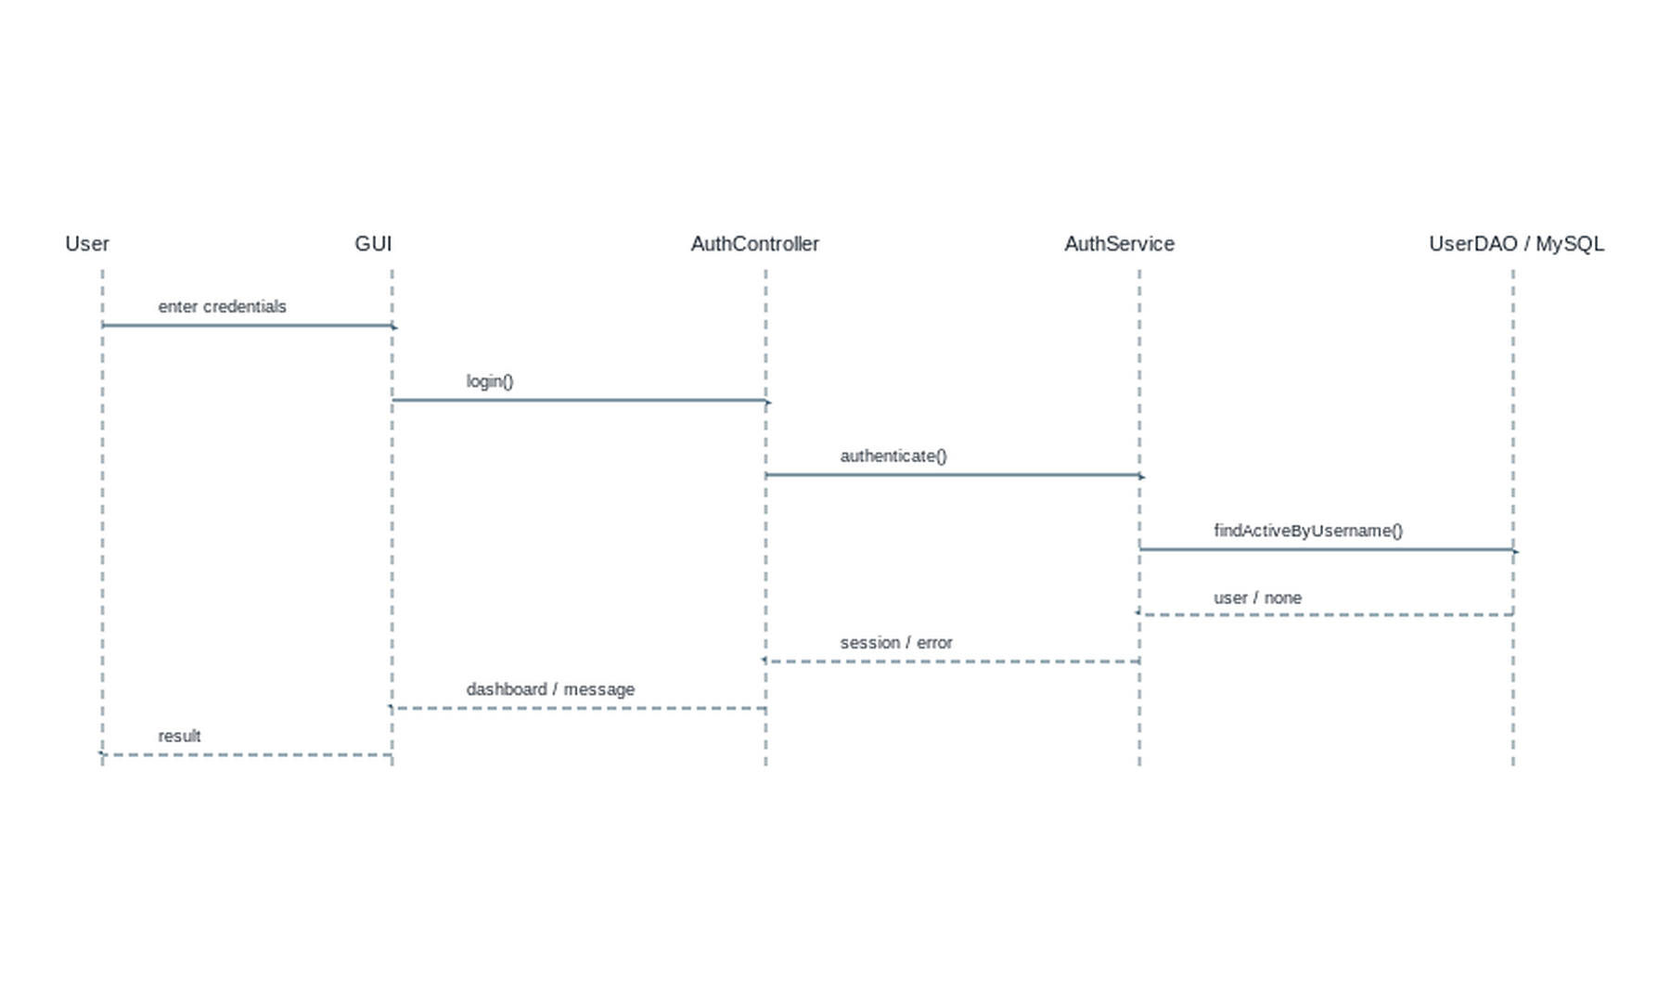
Figure 11. Login sequence.
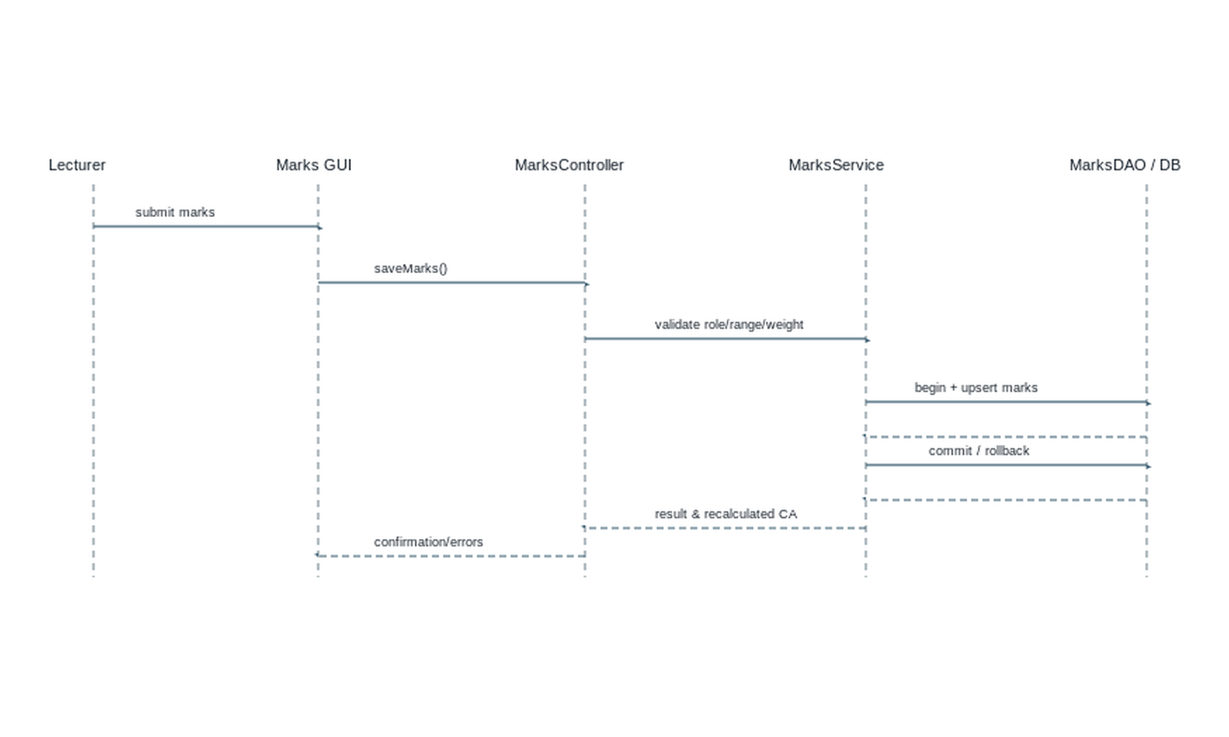
Figure 12. Lecturer marks-upload sequence.
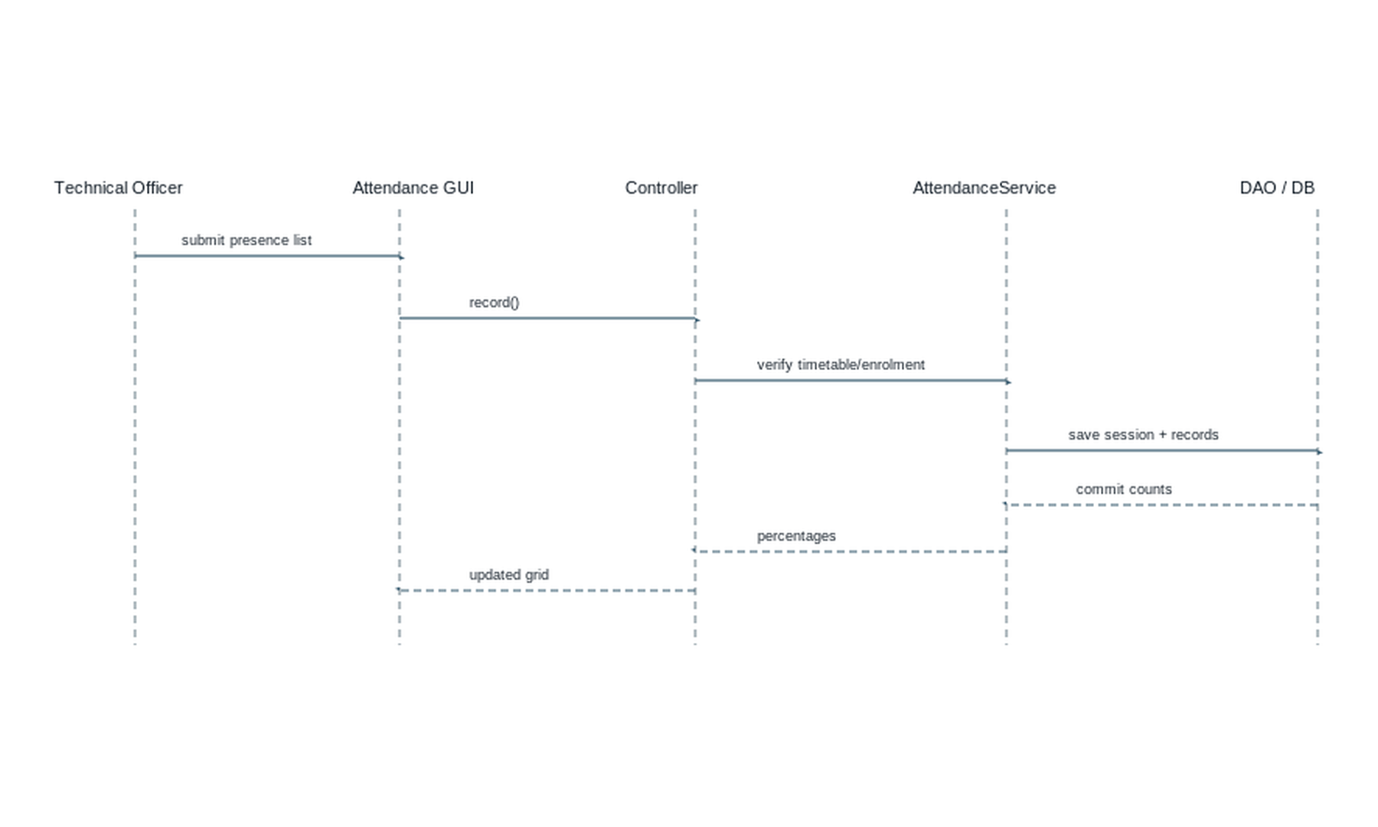
Figure 13. Technical Officer attendance sequence.
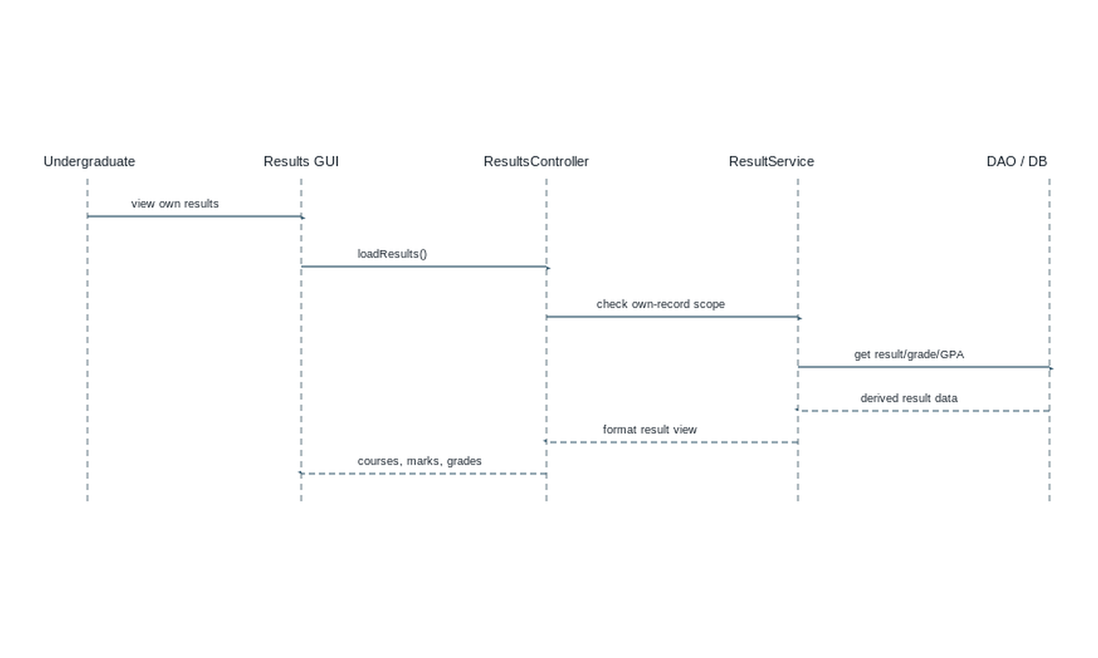
Figure 14. Student results-view sequence.

14.1 Eligibility-checking sequence
Actor: Lecturer or system result process. Messages: Eligibility GUI requests evaluation → Controller calls EligibilityService → service loads attendance, medical approvals, CA and configuration through DAOs → service applies BR-005 to BR-010 → DAO may persist an auditable result snapshot → GUI displays eligible/not eligible and failed conditions. This is the same layered interaction pattern shown in Figures 11–14.

15. State Diagrams
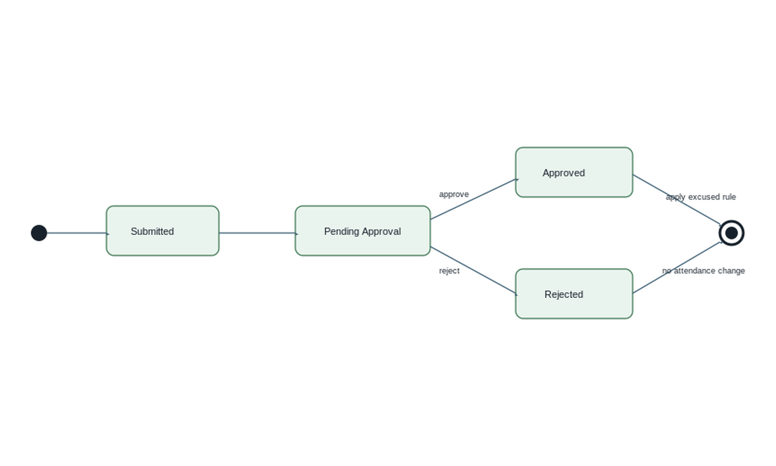
Figure 15. Medical Record state diagram. The submitted record is placed in Pending Approval until an authorised decision is recorded.
Useful secondary state: Assessment is Draft → Published → Marks Open → Locked. A published assessment cannot be changed if marks already exist without a controlled authorised revision/audit event.

16. Database Design

16.1 Design approach
The schema is normalised to practical third normal form: a person account is separated from role-specific data; student-to-offering, course-to-lecturer, and assessment-to-mark relationships use junction/child tables; derived GPA is calculated from results rather than duplicated as a permanent source of truth. Profile pictures use a controlled relative file path/UUID rather than BLOB to keep routine database backups and queries lightweight.

16.2 Keys, indexes and referential actions
Category | Specification
Primary keys | Every table has a surrogate INT/BIGINT auto-increment primary key, except users may use BIGINT. Business identifiers (username, course code, student number) are alternate unique keys.
Foreign keys | All relationship columns in the field specification are foreign keys. Use RESTRICT for academic parent records with history; use CASCADE only for true dependent children such as attendance_records when an unposted session is removed.
Unique constraints | users.username; undergraduates.student_no; departments.code; courses.course_code; course_offerings(course_id,semester_id,batch_id); course_enrollments(student_id,offering_id,attempt_no); assessments(offering_id,name); marks(assessment_id,enrollment_id); attendance_records(session_id,enrollment_id).
Important indexes | FK indexes; course_enrollments(student_id, status); attendance_sessions(offering_id, session_date); medical_records(student_id, approval_status); marks(enrollment_id); notices(publish_date, expiry_date); timetable_entries(timetable_id, day_of_week, start_time).
Validation constraints | credits > 0; mark 0–100; weight 0–100; attendance presence boolean; status values via CHECK/ENUM; start_time < end_time; approved date range valid. MySQL 8 CHECK constraints are used; service validation remains mandatory.

16.3 Relationship table
Parent table | Child table | Relationship | Foreign key | Cardinality | Explanation
users | admins/lecturers/technical_officers/undergraduates | role profile | user_id | 1 : 0..1 per role | Shared credentials, role-specific fields.
departments | batches, courses, lecturers, technical_officers | owns/employs | department_id | 1 : many | Academic department scope.
batches | undergraduates, course_offerings | contains/offered to | batch_id | 1 : many | Supports normal, repeat and batch-missed enrolments through enrolment status.
courses | course_components, course_offerings | defines/offers | course_id | 1 : many | Course definition is reused across semesters.
course_offerings | enrollments, assessments, sessions, materials | academic instance | offering_id | 1 : many | Current semester scoped operations.
undergraduates + offerings | course_enrollments | junction | student_id, offering_id | many : many | Captures attempt/status.
assessments + enrollments | marks | junction/score | assessment_id, enrollment_id | many : many | One score per enrolled student/assessment.
attendance_sessions + enrollments | attendance_records | junction/status | session_id, enrollment_id | many : many | Presence per student/session.
undergraduates | medical_records | has | student_id | 1 : many | Medical approval supports attendance eligibility rule.

17. ER Diagram
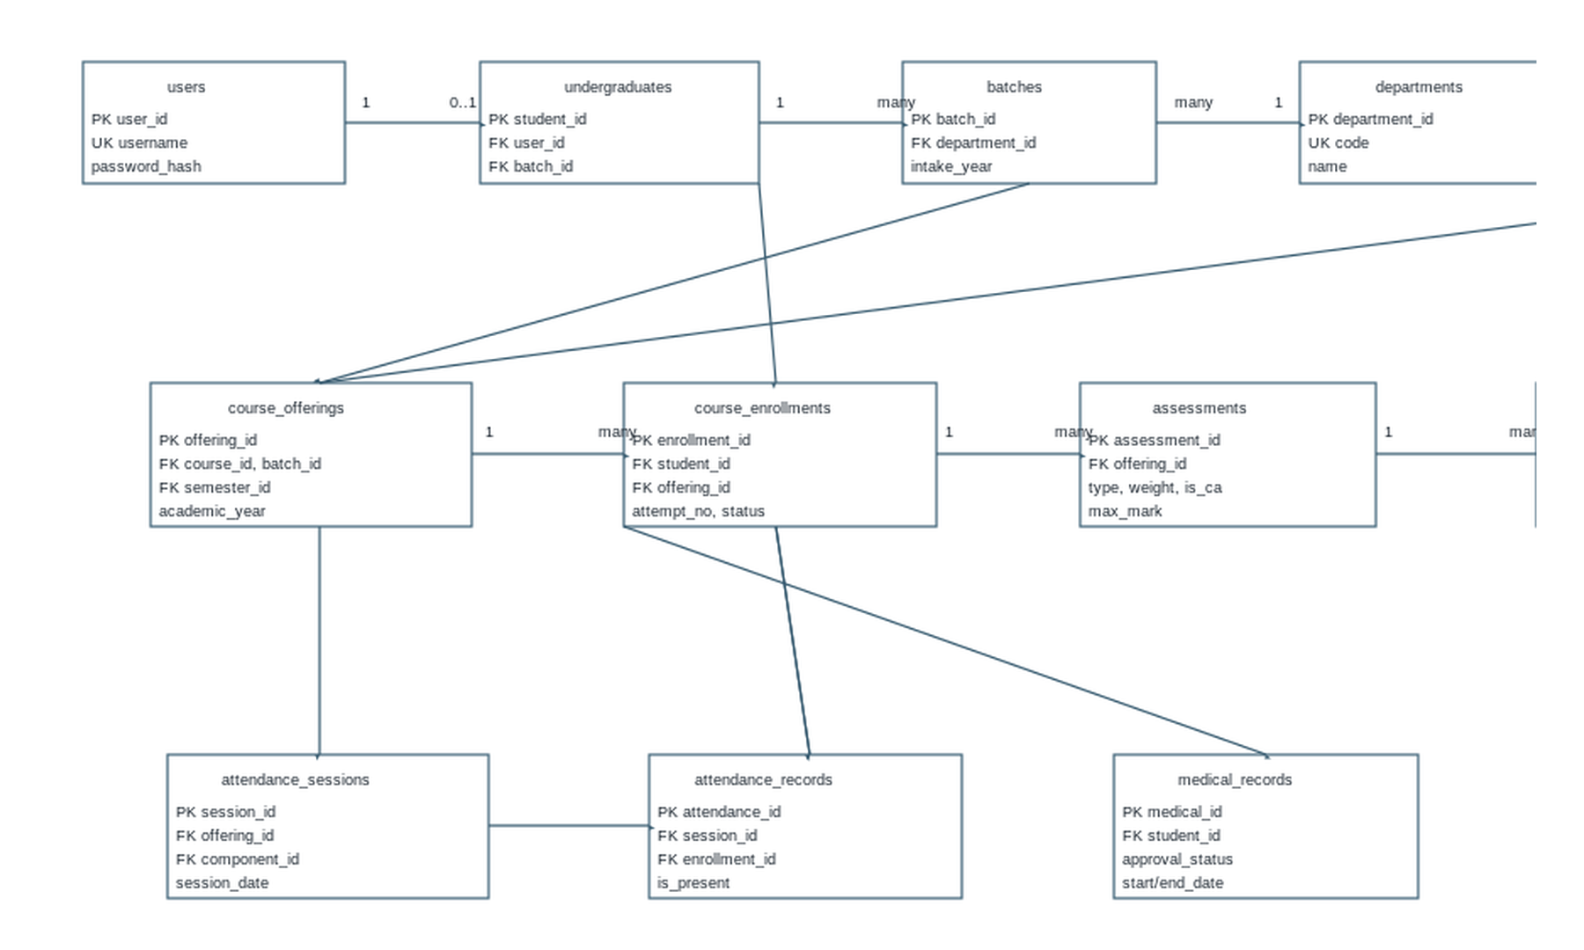
Figure 16. MySQL ER diagram. Lines identify valid FK-to-PK relationships; enrolments, marks and attendance records resolve many-to-many relationships.

18. Database Table Specifications
All table names are lowercase snake_case. Key: PK=primary key, FK=foreign key, UK=unique key. Data types are MySQL 8 types. DB-001: Every listed FK must reference a valid parent key. DB-002: Required foreign-key indexes, checks and unique rules from Section 16 shall be created.
Table | Field | Data type | Size | Constraints | Key | Description
users | user_id | BIGINT | — | NOT NULL AUTO_INCREMENT | PK | Account identifier
users | username | VARCHAR | 50 | NOT NULL | UK | Login name
users | password_hash | VARCHAR | 255 | NOT NULL | — | Salted password hash
users | role | ENUM | — | NOT NULL | INDEX | ADMIN/LECTURER/TECHNICAL_OFFICER/UNDERGRADUATE
users | email | VARCHAR | 120 | NOT NULL | UK | Contact email
users | is_active | BOOLEAN | — | NOT NULL DEFAULT TRUE | — | Soft access status
users | created_at | DATETIME | — | NOT NULL | — | Audit time
admins | admin_id | INT | — | NOT NULL AUTO_INCREMENT | PK | Admin identifier
admins | user_id | BIGINT | — | NOT NULL | FK, UK | → users.user_id ON DELETE RESTRICT
admins | full_name | VARCHAR | 120 | NOT NULL | — | Name
admins | phone | VARCHAR | 20 | NULL | — | Contact
departments | department_id | INT | — | NOT NULL AUTO_INCREMENT | PK | Department identifier
departments | code | VARCHAR | 15 | NOT NULL | UK | Department code
departments | name | VARCHAR | 120 | NOT NULL | — | Department name
departments | office_location | VARCHAR | 80 | NULL | — | Office
departments | is_active | BOOLEAN | — | DEFAULT TRUE | — | Status
batches | batch_id | INT | — | NOT NULL AUTO_INCREMENT | PK | Batch identifier
batches | department_id | INT | — | NOT NULL | FK | → departments, RESTRICT
batches | intake_year | YEAR | — | NOT NULL | — | Intake year
batches | programme | VARCHAR | 100 | NOT NULL | — | Programme title
batches | batch_code | VARCHAR | 20 | NOT NULL | UK | Human-readable batch
undergraduates | student_id | INT | — | NOT NULL AUTO_INCREMENT | PK | Student identifier
undergraduates | user_id | BIGINT | — | NOT NULL | FK, UK | → users, RESTRICT
undergraduates | batch_id | INT | — | NOT NULL | FK, INDEX | → batches, RESTRICT
undergraduates | student_no | VARCHAR | 25 | NOT NULL | UK | Institution student number
undergraduates | full_name | VARCHAR | 120 | NOT NULL | — | Name
undergraduates | profile_picture_path | VARCHAR | 255 | NULL | — | Controlled file path/UUID
lecturers | lecturer_id | INT | — | NOT NULL AUTO_INCREMENT | PK | Lecturer identifier
lecturers | user_id | BIGINT | — | NOT NULL | FK, UK | → users
lecturers | department_id | INT | — | NOT NULL | FK, INDEX | → departments
lecturers | full_name | VARCHAR | 120 | NOT NULL | — | Name
lecturers | phone | VARCHAR | 20 | NULL | — | Contact
lecturers | designation | VARCHAR | 80 | NULL | — | Role title
technical_officers | officer_id | INT | — | NOT NULL AUTO_INCREMENT | PK | Officer identifier
technical_officers | user_id | BIGINT | — | NOT NULL | FK, UK | → users
technical_officers | department_id | INT | — | NOT NULL | FK, INDEX | → departments
technical_officers | full_name | VARCHAR | 120 | NOT NULL | — | Name
technical_officers | phone | VARCHAR | 20 | NULL | — | Contact
technical_officers | designation | VARCHAR | 80 | NULL | — | Role title
courses | course_id | INT | — | NOT NULL AUTO_INCREMENT | PK | Course identifier
courses | department_id | INT | — | NOT NULL | FK, INDEX | → departments
courses | course_code | VARCHAR | 20 | NOT NULL | UK | Course code
courses | title | VARCHAR | 180 | NOT NULL | — | Course title
courses | total_credits | DECIMAL | 3,1 | NOT NULL CHECK >0 | — | Total credits
courses | is_active | BOOLEAN | — | DEFAULT TRUE | — | Status
course_components | component_id | INT | — | NOT NULL AUTO_INCREMENT | PK | Component identifier
course_components | course_id | INT | — | NOT NULL | FK, INDEX | → courses
course_components | component_type | ENUM | — | NOT NULL | — | THEORY/PRACTICAL
course_components | credits | DECIMAL | 3,1 | NOT NULL CHECK >0 | — | Component credits
course_components | planned_sessions | INT | — | NOT NULL DEFAULT 15 CHECK >0 | — | Planned sessions

Table | Field | Data type | Size | Constraints | Key | Description
semesters | semester_id | INT | — | NOT NULL AUTO_INCREMENT | PK | Semester identifier
semesters | academic_year | VARCHAR | 9 | NOT NULL | UK pair | e.g., 2026/2027
semesters | semester_no | TINYINT | — | NOT NULL CHECK IN (1,2) | UK pair | Semester number
semesters | start_date | DATE | — | NOT NULL | — | Start
semesters | end_date | DATE | — | NOT NULL CHECK >start_date | — | End
course_offerings | offering_id | INT | — | NOT NULL AUTO_INCREMENT | PK | Course instance
course_offerings | course_id | INT | — | NOT NULL | FK | → courses
course_offerings | batch_id | INT | — | NOT NULL | FK | → batches
course_offerings | semester_id | INT | — | NOT NULL | FK | → semesters
course_offerings | coordinator_id | INT | — | NULL | FK | → lecturers
course_offerings | status | ENUM | — | DEFAULT 'OPEN' | UK tuple | OPEN/CLOSED
course_enrollments | enrollment_id | INT | — | NOT NULL AUTO_INCREMENT | PK | Enrollment identifier
course_enrollments | student_id | INT | — | NOT NULL | FK, INDEX | → undergraduates
course_enrollments | offering_id | INT | — | NOT NULL | FK, INDEX | → course_offerings
course_enrollments | attempt_no | TINYINT | — | NOT NULL DEFAULT 1 | UK tuple | Attempt number
course_enrollments | student_status | ENUM | — | NOT NULL | — | NORMAL/REPEAT/BATCH_MISSED
course_enrollments | enrollment_status | ENUM | — | NOT NULL | — | ACTIVE/COMPLETED/WITHDRAWN
assessments | assessment_id | INT | — | NOT NULL AUTO_INCREMENT | PK | Assessment identifier
assessments | offering_id | INT | — | NOT NULL | FK, INDEX | → offerings
assessments | name | VARCHAR | 100 | NOT NULL | UK pair | Assessment name
assessments | assessment_type | ENUM | — | NOT NULL | — | ASSIGNMENT/QUIZ/MID/PRACTICAL/CA/FINAL/OTHER
assessments | weight_percent | DECIMAL | 5,2 | NOT NULL CHECK 0–100 | — | Contribution
assessments | is_ca_component | BOOLEAN | — | NOT NULL | — | Counts toward CA
marks | mark_id | INT | — | NOT NULL AUTO_INCREMENT | PK | Mark identifier
marks | assessment_id | INT | — | NOT NULL | FK | → assessments
marks | enrollment_id | INT | — | NOT NULL | FK | → enrollments
marks | score | DECIMAL | 5,2 | NOT NULL CHECK 0–100 | UK pair | Raw mark out of 100
marks | entered_by | INT | — | NOT NULL | FK | → lecturers
attendance_sessions | session_id | INT | — | NOT NULL AUTO_INCREMENT | PK | Session identifier
attendance_sessions | offering_id | INT | — | NOT NULL | FK, INDEX | → offerings
attendance_sessions | component_id | INT | — | NOT NULL | FK | → components
attendance_sessions | session_date | DATE | — | NOT NULL | UK tuple | Held date
attendance_sessions | timetable_entry_id | INT | — | NULL | FK | → timetable_entries
attendance_sessions | recorded_by | INT | — | NOT NULL | FK | → technical_officers
attendance_records | attendance_id | INT | — | NOT NULL AUTO_INCREMENT | PK | Attendance identifier
attendance_records | session_id | INT | — | NOT NULL | FK | → sessions, CASCADE if unposted removed
attendance_records | enrollment_id | INT | — | NOT NULL | FK | → enrolments
attendance_records | is_present | BOOLEAN | — | NOT NULL | UK pair | Presence state

Table | Field | Data type | Size | Constraints | Key | Description
medical_records | medical_id | INT | — | NOT NULL AUTO_INCREMENT | PK | Medical identifier
medical_records | student_id | INT | — | NOT NULL | FK, INDEX | → undergraduates
medical_records | offering_id | INT | — | NULL | FK | Related offering where known
medical_records | medical_date | DATE | — | NOT NULL | — | Submission/evidence date
medical_records | start_date/end_date | DATE | — | NOT NULL | CHECK valid range | Excused period
medical_records | reason_details | VARCHAR | 500 | NOT NULL | — | Reason
medical_records | approval_status | ENUM | — | NOT NULL DEFAULT 'PENDING' | INDEX | PENDING/APPROVED/REJECTED
medical_records | affects_eligibility | BOOLEAN | — | NOT NULL DEFAULT FALSE | — | Approved rule flag
course_materials | material_id | INT | — | NOT NULL AUTO_INCREMENT | PK | Material identifier
course_materials | offering_id | INT | — | NOT NULL | FK | → offerings
course_materials | lecturer_id | INT | — | NOT NULL | FK | → lecturers
course_materials | title | VARCHAR | 150 | NOT NULL | — | Title
course_materials | file_path | VARCHAR | 255 | NOT NULL | — | Controlled resource path
notices | notice_id | INT | — | NOT NULL AUTO_INCREMENT | PK | Notice identifier
notices | title | VARCHAR | 180 | NOT NULL | — | Heading
notices | body | TEXT | — | NOT NULL | — | Message
notices | audience | ENUM | — | NOT NULL | — | ALL/role/batch
notices | publish_date | DATETIME | — | NOT NULL | INDEX | Publish time
notices | expiry_date | DATETIME | — | NULL CHECK > publish | INDEX | Optional expiry
timetables | timetable_id | INT | — | NOT NULL AUTO_INCREMENT | PK | Timetable identifier
timetables | department_id | INT | — | NOT NULL | FK | → departments
timetables | semester_id | INT | — | NOT NULL | FK | → semesters
timetables | title | VARCHAR | 100 | NOT NULL | — | Timetable title
timetable_entries | timetable_entry_id | INT | — | NOT NULL AUTO_INCREMENT | PK | Entry identifier
timetable_entries | timetable_id | INT | — | NOT NULL | FK, INDEX | → timetables
timetable_entries | offering_id | INT | — | NOT NULL | FK | → offerings
timetable_entries | component_id | INT | — | NOT NULL | FK | → components
timetable_entries | day_of_week | ENUM | — | NOT NULL | INDEX | MON–SUN
timetable_entries | start_time/end_time | TIME | — | NOT NULL | CHECK start < end | Scheduled time
timetable_entries | location | VARCHAR | 80 | NOT NULL | — | Room/lab
grades | grade_id | INT | — | NOT NULL AUTO_INCREMENT | PK | Grade-scheme row
grades | scheme_version | VARCHAR | 30 | NOT NULL | UK tuple | e.g. UGC-12-2024
grades | grade_letter | VARCHAR | 3 | NOT NULL | UK tuple | Grade label
grades | min_mark/max_mark | DECIMAL | 5,2 | NOT NULL | CHECK 0–100 | Inclusive range
grades | grade_point | DECIMAL | 3,2 | NOT NULL CHECK 0–4 | — | GPA value
audit_logs | audit_id | BIGINT | — | NOT NULL AUTO_INCREMENT | PK | Audit event
audit_logs | user_id | BIGINT | — | NULL | FK, INDEX | Actor
audit_logs | action | VARCHAR | 50 | NOT NULL | — | CREATE/UPDATE/etc.
audit_logs | entity_name/entity_id | VARCHAR/BIGINT | 80/— | NOT NULL | — | Changed record
audit_logs | occurred_at | DATETIME | — | NOT NULL | INDEX | Event time

19. Validation Rules
Field / input | Validation | Error message
Username | 3–50 letters/digits/._; unique | Enter a unique username using 3–50 allowed characters.
Password | Minimum 8 characters; stored only as a hash | Password must contain at least 8 characters.
Student ID | Required, unique, permitted institutional format | Enter a unique valid student ID.
Email | Required valid email syntax; unique for account | Enter a valid email address.
Phone | Optional/required by profile policy; 7–20 permitted digits and + - spaces | Enter a valid phone number.
Course code | Required, unique, 3–20 uppercase letters/digits/hyphen | Enter a unique valid course code.
Credit value | Decimal greater than 0 | Credit value must be greater than zero.
Assessment weight | 0 < weight ≤ 100; total published plan = 100 | Assessment weights must total 100%.
Marks | 0 ≤ marks ≤ 100 | Marks must be between 0 and 100.
Attendance | Computed 0% ≤ attendance ≤ 100%; one record per enrolled student/session | Attendance record is invalid or already exists.
Medical date/range | Not future; end date not before start date; reason required | Enter a valid medical date range and reason.
Timetable | Start before end; no configured room/lecturer/course overlap | This timetable entry conflicts with an existing entry.

20. Error and Exception Handling
Error / exception | Java handling | User response
Invalid login | AuthenticationException; log attempt without password. | “Username or password is incorrect.”
Duplicate username/enrolment | Pre-check; catch SQLIntegrityConstraintViolationException and map to ValidationException. | State the duplicate field/relationship.
Database unavailable / SQL failure | DataAccessException wraps SQLException; transaction rollback; log technical cause. | Safe connection message; no SQL detail.
Invalid marks/attendance/medical | Domain ValidationException before DAO call. | Show field-level correction message.
Missing required field | GUI and service validation. | Highlight required field.
Unauthorised operation | AuthorizationException, audit event. | “You do not have permission for this action.”
Record not found | NotFoundException from service/DAO result mapping. | “The requested record is unavailable.”
Use try for risk-prone operations, catch for specific exception types, finally or try-with-resources for cleanup, and custom exceptions for business-level errors. Controllers must not swallow errors; they log correlation details and return a recoverable GUI state.

21. GUI Requirements
All screens shall have a clear title, logged-in role/name, navigation, validation messages near inputs, confirmation before destructive/locking actions, and only role-authorised controls.

1. Login
Username/password fields, Login button, error label; all roles; validates active credentials.

2–5. Role Dashboards
Admin, Lecturer, Technical Officer, Undergraduate shortcuts, scoped alerts and summary counts; read-only summary data.

6. User Management
Admin: role selector, profile form, search table, Create/Update/Deactivate buttons; validates unique account identity.

7. Student Management
Admin: student/batch/contact/status fields and listing; validates student ID, batch and role link.

8. Course Management
Admin: course/offering/component/credit fields, assignment and enrolment tables; validates codes, credits, duplicates.

9. Attendance
Technical Officer: timetable session selector, component filter, presence grid, Save; lecturer/student view only by scope.

10. Medical Management
Technical Officer: student/course/date/reason/evidence/status controls; approval list and validation messages.

11. Marks Entry
Lecturer: offering/assessment/batch selectors, marks table, Save/Update; requires 0–100 and course assignment.

12. Eligibility
Lecturer: student/batch/course filters, attendance/CA/final status and reasons; student sees own status.

13–14. Grade / GPA Screens
Lecturer and student: courses, credits, final marks, grades, grade points, SGPA/CGPA; no manual edits.

15. Timetable
Admin editor; other role-specific read views; day/time/location grid with conflict validation.

16. Notice
Admin compose/publish/expire controls; all roles read targeted notices.

17. Course Materials
Lecturer add/edit/delete authorised materials; enrolled students view list.

18. Profile
Own profile fields; username/password locked; undergraduate contact/picture-only edit.

19. Reports
Authorised filters, preview table, print/export action; no raw data outside scope.

22. Reports
Report | Contents / filters | Authorised users
Student attendance | Student, course, component, present/scheduled/excused, percentage | Lecturer, Technical Officer, own student
Batch / course attendance | Batch/course/component summary and individual rows | Lecturer, Technical Officer
CA / final marks | Course, assessment, batch/student marks, weighted results | Lecturer; own student results
Eligibility | Attendance, CA, final status and reasons | Lecturer; own student
Grades / course results | Credits, final mark, grade, grade point | Lecturer; own student
SGPA / CGPA | Counted courses, credits, grade points and calculated values | Lecturer; own student
Medical records | Student, period, reason, approval and eligibility effect | Lecturer, Technical Officer, own student
Student profile | Permitted identity/contact/batch status | Admin, Lecturer; own student

23. Requirement Traceability Matrix
Requirement ID | Requirement | Module | Class | Database table | Use case
FR-001 | Authenticate users | Authentication | User, AuthService | users, audit_logs | Login
FR-002 | Maintain profiles | User Management | User + role subclasses | users, role tables | Manage Users
FR-003 | Maintain courses/timetable/notices | Course/Notice/Timetable | Course, Timetable, Notice | courses, components, entries, notices | Manage Courses/Notices/Timetables
FR-005 | Manage materials | Course Materials | CourseMaterial | course_materials | Course Materials
FR-006/007 | Configure and enter marks | Assessment/Marks | Assessment, Marks, MarksService | assessments, marks | Upload Marks
FR-008/009 | Theory/practical attendance | Attendance | AttendanceSession, AttendanceRecord | attendance_sessions, attendance_records | Manage Attendance
FR-010 | Medical approval | Medical | MedicalRecord | medical_records | Medical Records
FR-011 | Eligibility | Eligibility | EligibilityPolicy | enrolments, marks, attendance, medicals | View Eligibility
FR-012 | Grades / SGPA / CGPA | Grade/GPA | Grade, GPA | grades, marks, enrollments | View Results/GPA
FR-013 | Notices/timetable | Notice/Timetable | Notice, TimetableEntry | notices, timetables, entries | View Notices/Timetable
FR-014 | Reports/audit | Reports | ReportService, AuditLog | all relevant tables, audit_logs | Reports

24. Assumptions and Limitations

24.1 Assumptions
Category | Assumption
Academic | Faculty supplies final approved course offerings, enrollment selection, assessment weights and any programme-specific policy exception.
Technical | All client computers can run the selected Java GUI runtime and reach the authorised MySQL server.
Database | Profile image files are stored in an access-controlled application directory and database stores only controlled paths/UUIDs.
Attendance | 15 sessions are planned for each theory/practical component; approved medical absences are removed from the denominator (BR-009).
Grading | UGC Circular 12/2024 scheme applies to the relevant Technology-stream cohort; Faculty must confirm any local exception and repeat-result selection rule.
Security | Admin provisions initial accounts securely; password reset procedure is a controlled institutional process outside this mini-project scope.

24.2 Limitations
- Desktop application for a single institutional deployment; no mobile app or public Internet-facing portal.
- MySQL availability and local network connectivity are required for shared live data.
- Medical evidence is represented as validated details/reference; a public online upload portal is not included.
- The system calculates from approved configured data but does not replace formal examination-board approval.

25. Future Enhancements
- Web and mobile applications with secure single sign-on.
- Email and SMS notifications for notices, eligibility and timetable changes.
- Parent portal, online medical upload workflow, and document scanning.
- Advanced analytics for attendance/assessment trends and risk indicators.
- Cloud deployment, automated backups, and University LMS integration.
These items are explicitly future enhancements, not current functional requirements.

26. Conclusion
This SRS defines a feasible Java + MySQL GUI mini-project with scope-controlled roles, configurable academic assessment, correct theory/practical attendance treatment, medical approval, eligibility, grades, SGPA/CGPA, and an OOP-oriented layered design. The explicit assumptions protect the project from presenting unconfirmed local academic policies as official rules.

Appendix A — Sample Data
DB-003 Seed data shall include 1 Admin, at least 5 Lecturers, at least 4 Technical Officers, and at least 20 Undergraduates. The following example has 24 students and supports all required categories/scenarios.
Population | Example structure
Admin | ADM001 — one active administrator.
Lecturers | LEC001–LEC005 — five lecturers assigned across Faculty of Technology courses.
Technical Officers | TO001–TO004 — four officers, department scoped.
Normal undergraduates | STU001–STU016 — 16 active normal students in FOT-2025 batch.
Repeat undergraduates | STU017–STU020 — four course enrolments with student_status=REPEAT, attempt_no=2.
Batch-missed undergraduates | STU021–STU024 — four course enrolments with student_status=BATCH_MISSED in the appropriate later offering.

Attendance test case | Component example | Required demonstration
STU001 | Theory 13/15; practical 14/15 | >80% without medical
STU002 | Theory 12/15; practical 12/15 | Exactly 80%
STU003 | Theory 10/15; practical 10/15 | <80%, no medical
STU004 | Theory 13/15 plus approved medical absence | >80%, with medical
STU005 | Theory 8/15, approved medical does not bring percentage to 80% | <80%, with medical

Appendix B — Glossary
Term | Meaning
Academic year | Institutional year used with a semester to identify an offering.
Assessment plan | Configured assessment components and weights for one course offering.
Course offering | A course delivered to a selected batch in a selected semester/year.
Eligibility | Derived status based on the stated attendance and CA business rules.
Final mark | Weighted result derived from configured assessment marks.
Soft delete | Deactivating a record instead of destroying academic history.
Faculty of Technology Academic Management System — SRS v1.0 | ICT2132 Object Oriented Programming Practicum

